Differential Equations Coursework

Introduction

A differential equation is an equation that involves derivatives of a function or functions. In the following work I will be investigating how long a runway will need to be for a plane to land, with a mass of 120,000kg, during a 26 second period. This will be done using a suitable mathematical model that will explain the nature of the forces acting on the plane.

In this investigation there are many assumptions that I will need to make in order to get the most accurate model possible, these assumptions will be stated below.

The assumptions that I will make are:

* There is no friction in the landing gear. This would cause a greater time taken to come a complete stop
* The plane has a point mass. This means that the plane would be in equilibrium and not unbalanced.
* The runway is straight and uniformed. Otherwise the plane would be subject to conditions that could either slow the plane down or speed it up, which extend or shorten the time and distance respectively.
* No obstructions on the runway. As this would cause the plane to have to move out of the way or be stopped immediately
* Negligible air resistance. Air resistance would cause the plane to slow down so calculating without air resistance means that we would find the maximum distance of the runway.
* The wheels do not skid. This would cause the time to come to stop to increase as the braking isn’t even.
* Horizontal approach. This would increase the time for the braking force to be applied as the wheels would otherwise not be on the surface at the same time.
* The plane lands at the very start of the runway and stops at the end of the runway. If the plane lands further in on the runway and not the very start the end of the runway will have to be elongated.
* No bad weather. Weather can affect the runway conditions and forces acting on the plane.
* No forward force of the engine. This would cause the plane to carry on moving forward therefore the length of the runway would have to be extended.
* The plane doesn’t taxi at the end and comes to a stop. Otherwise the runway will have to be extended and it would take longer for the plane to stop.

Modelling the investigation

Table of values

|  |  |  |  |  |  |  |  |  |  |  |  |  |  |  |
| --- | --- | --- | --- | --- | --- | --- | --- | --- | --- | --- | --- | --- | --- | --- |
| t | 0 | 1 | 2 | 3 | 4 | 5 | 6 | 7 | 8 | 9 | 10 | 11 | 12 | 13 |
| v | 96 | 89 | 82 | 77 | 72 | 68 | 64 | 61 | 58 | 55 | 50 | 46 | 41 | 38 |

|  |  |  |  |  |  |  |  |  |  |  |  |  |  |
| --- | --- | --- | --- | --- | --- | --- | --- | --- | --- | --- | --- | --- | --- |
| t | 14 | 15 | 16 | 17 | 18 | 19 | 20 | 21 | 22 | 23 | 24 | 25 | 26 |
| v | 34 | 31 | 27 | 24 | 21 | 18 | 16 | 13 | 10 | 8 | 5 | 3 | 0 |

Graph

The graph shows me that there are two sections to the process of landing on the runway, 0-9 seconds is one section and then 10-26 seconds is the other section. This is seen as there is a kink in the graph at 9 seconds; this informs us that this is when the brakes are applied to the aeroplane. Therefore there are two models; one before the brakes are applied and one after the brakes are applied as seen below. The area underneath the curve is what we need to find as this will tell us the length of runway needed for the plane to land.

Resistance

Direction of movement

Gravity

Resistance + Braking force

Direction of movement

Gravity

Model of plane: 0-9 seconds, before braking is applied

Model of plane: 10-26 seconds, when braking is applied

The 2 models above show the forces acting upon the plane at the two different sections, gravity and resistance is common in both but after 9seconds the brakes are applied causing a greater resistance against the direction of movement. These two models will help me visualize the problems when tackling the formulas.

First estimation

To get the first estimation for the area underneath the graph I will be using the trapezium rule which the formula is .

I will be using a h value of 1 as I have the values given for those intervals.

Application

Using the trapezium rule I was able to deduce a basic estimate for the area under the curve, the value that I calculated was 1059m. Therefore I know that I will need to make my runway 1059m long or 1.059km, however because I was using the trapezium rule the answer isn’t very accurate and by using differential equations I can find a more accurate if not the exact value. But now I do have a value to compare my new values with.

Run-through 1

Because I do not have the equation to my graph I will need to create a suitable model for it, this will be done by using the known forces being applied to my plane at section 1 and section 2 which will then be added together to find an approximation for the area.

Section 1

Because I know forces area acting upon aeroplane we can start from Newton’s second law:

We also know that the force is proportional to negative velocity as the aeroplane is slowing down

The acceleration is known as the differential of the equation for which we do not know but it can still be written down as:

With everything I have written I can create a basic derivative of our formula with many unknowns

From the context of the investigation we know that the aeroplane has a mass of 120,000 which we can substitute into the formula above

To find the equation we will need to re-arrange and integrate the formula above

The formula above is our first basic formula for the graph however to find the unknown c and k values we sub in some values from the table of values on page 2

Next I will find the first estimate for k

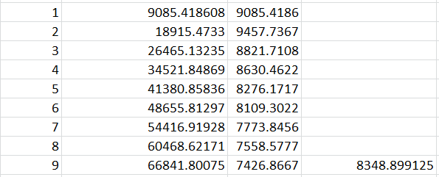Now that I have found the first estimate for k I will use Microsoft Excel for all the possible values of k between 0-9 seconds and the average them.

These are the values for k between 1-9 and the average of these values and the formula I used and I can put it back into the equation of the line and re-arrange it to make v the subject.

Now that I have found an equation for v I can sub in t values between 0-9 seconds and see how big the errors are, if any.

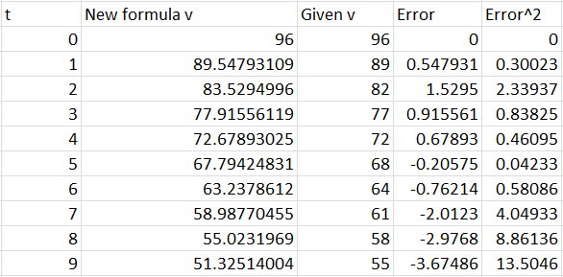

This table above shows the values of v that I calculated using the new formula, the values given and then working out the error and error2 to help us see how accurate this model is. From the table above I can deduce that as the time goes on the error2 gets larger and the sum of my error2 is 30.9773 which our aim is to reduce it to as close to 0 as possible.

Length of runway between 0-9 seconds

To work out the length of the runway between 0-9 seconds I will need to integrate the formula for the graph.

This is the length of the runway between 0-9 seconds using the first iteration of the formula.

Section 2

I am now moving on to the second section of this run-through, I will now be finding the length of the runway between 9-26 seconds. In this section there is an extra component which is the breaking force, this causes the airplane to slow down even further.

I am assuming that k is unchanged from previous workings and as I am starting the second part I will need to change t=9 to t=0 as we are using it as a new starting point.

Now that we know what the braking force is we can sub it back into the formula and re-arrange in to find v in terms of t and compare it to the data sets given.

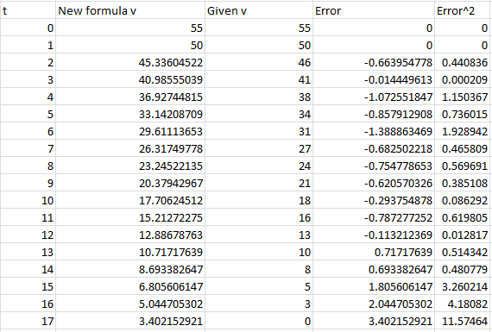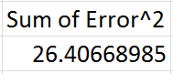

Above is the table of values for estimating the values of v using the new formula and comparing it to the given values to determine how accurate the formula is. I will now need to integrate the formula with the new limits to find the length of the runway.

The length of the runway between 9 – 26 seconds is

When I add the length of the runway from both sections I get:

Run-through 2

By looking through my work I got errors for my values and due to this I know that I can make my values even more accurate by changing the force being proportional to to have the force proportional to . This will make my model even more accurate because the new values of are closer to the given values than that of I will be doing the same method as the previous runthrough, splitting the workings into two sections, between 0-9 seconds before the brakes are applied and then 9-26 seconds after the brakes have been applied.

Section 1

I will be starting of the same as before by using but instead of I will be using

With this I can put it into Newton’s Law, with the acceleration staying the same as before:

From this I can re-arrange to get the acceleration to be:

To find the equation of the line I need re-arrange and then integrate the formula above:

Now that we have got a basic formula for our model I can sub in the given values to find the unknowns c and k.

Now that I know that I have found the first estimate for k I can go into Excel like before I find an average for the values of k between 0-9 seconds using:

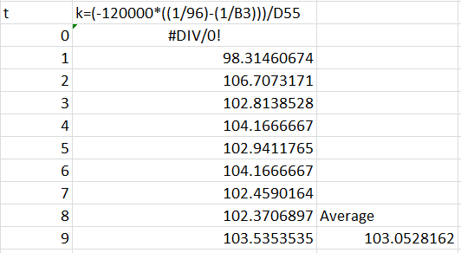

Now that I have a more accurate value for k I can plug it back into the formula.

Now I can re-arrange the formula to make the subject:

Now that I have got my equation for between 1-9 seconds I can plug in to find the estimates for and compare them to the given values and calculate the errors to see how small or large they are.

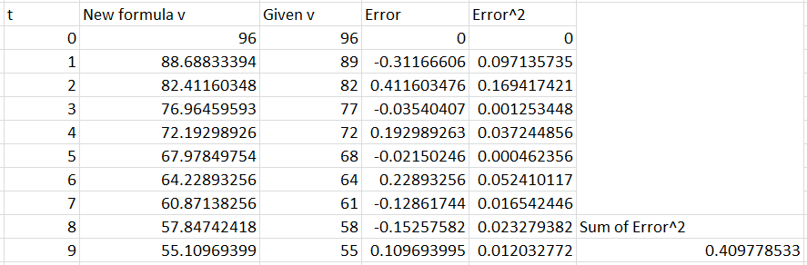

This table above shows all the values of I got through my formula, it also shows the errors between my values and the given ones and it gave me a sum error of 0.4098 4d.p. which compared to my previous error of 30.9773 it is significantly more accurate as the error is smaller.

Length of runway between 0-9 seconds

To find the length of the runway I will need to integrate my equation between the limits of 9 and 0.

So from above we have worked out that the length of the runway between 0-9 seconds is 646.297m 3d.p.

Section 2

Now that I have calculated the length of the runway between 0-9 seconds I need to move onto the second section of calculating the length of the runway between 9-26 seconds to do this I will start of the same as previously as it is a similar calculation with the added braking force of the airplane:

When integrating this I used the formula that was given to me in the formula booklet:

By plugging in the given values I can work out what the value of C, the value for k stays unchanged from the previous section. As I am starting from 9 seconds I have to change it to be 0 seconds because it is our new initial time.

I now need to find out what the breaking force is:

By using the formula above I can find out what my Value for braking force is, but to do so I will need to find out what is and this is shown in the table below.

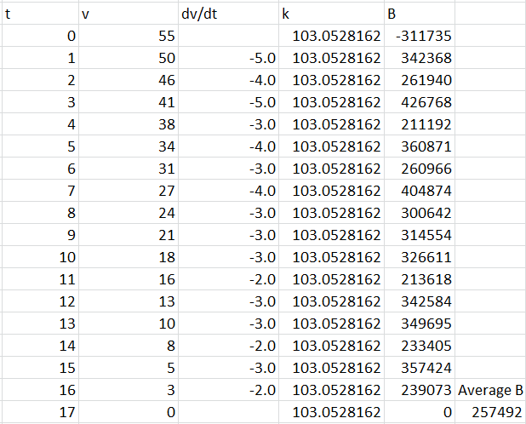

And from this I can see that my average braking force is which I can sub back into my formula and re-arrange to make v the subject to get a general formula.

Now that I have got a formula for v I can sub in the values and find out my new values and compare them to the given ones to determine the accuracy of my method.

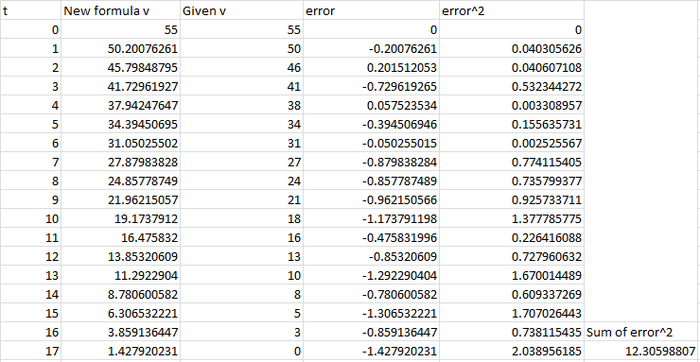This table above shows all the values I got from calculating my new v as well as the error between them and the given values. The Sum of the error2 is 12.30598807 which is approximately half of the error2 sum of my first run-through of 26.407

Length of runway between 9-26 seconds

To find out the length of the runway between 9-26 seconds I will need to integrate my formula with respects to 0 and 17, this will give me the area under the curve which is the length of the runway.

The length of the runway between 9-26 seconds

Now that I have calculated the length of the runway between 9-26 seconds I can add it together with the length between 0-9 seconds to find a more accurate total length of the runway which is:

The length of the runway is 1070.693m long.

Write up

Error Analysis

When calculating my data I made a few errors in my calculations which many of them were fixed to get accurate data. The main problem that caused me grief was the fact that I got an error2 sum of 159 for my second section of my second run-through but after rigorous working I managed to get my error down to roughly 12 which is a massive decrease from 159 and by doing this I managed to get a more accurate length of my runway.

Conclusion

For my 3 sets of data I got 1059m, 1054.009m and 1070.693m all to 3d.p. for my Trapezium rule, 1st run-through and 2nd run-through respectively, the most accurate method that was used was when I subbed v2 for v. When I was working out my length I split down the process into two sections, in section 1 I was working out the length of the runway before the plane applies its braking, this would mean that there is no extra braking force contributing to the speed of the plane. Section 2 was working out the length of the runway when braking force is applied, this would make the plane slow down even faster, and this would mean that the length of the runway would be shorter as it takes less time to come to a complete stop.

All of the working done in these previous pages were made with many assumptions in mind whereas in the real world these assumptions would have had a large impact on the length of my runways, for example weather conditions could impact how much more thrust or resistance the plane would face when landing as this would cause the runway to have be longer or shorter respectively. By also comparing my data to the given data I would get marginally more accurate each time having the error getting smaller for each value.

If I were to do this investigation again there would be a few things that I would change or improve. For example if I would carry on improving my methods increasing the amount of run-throughs I did, this would let me achieve an even more accurate number for the length of my runway. If it were possible as well I would want to use more accurate starting data, all of the data that was given to me was in integer form, and my data would be made more accurate if the given velocities were more accurate as well. Another way to improve my work was to add in my assumptions to affect my data like weather conditions.